**Roman Numerals**

ss ½ or 0.5

I or i 1

V or v 5 Cannot be used more than once and cannot be subtracted.

X or x 10

L or l 50 Cannot be used more than once and cannot be subtracted.

C or c 100

D or d 500 Cannot be used more than once and cannot be subtracted.

M or m 1000

**Solids**

1kg 1000g

1g 1000mg

1mg 1000mcg

1gr 64.8mg ~65mg

1oz 28.35g ~30g

1lb 454.54g ~480g 16oz

2.2lb 1kg

**Liquids**

1L 1000mL

1mL 20gtts (unless given a calibration factor)

1fl oz 29.57mL ~30mL

1pt 16fl oz 473mL ~480mL

1qt 32fl oz 946mL

1gal 4qt 8pt 138oz

1tsp 5mL

1tbsp 15mL

3tsp 1tbsp

Convert 12 kg to oz

1kg = 2.2lb

1lb = 16oz

12kg * (2.2lb/1kg) = 26.4lb

26.4lb * (16oz/1lb) = 422.4oz

Convert 7oz to gtts

1floz = 29.57mL

1mL = 20gtts

7oz * (29.57mL/1oz) = 206.99mL

206.99mL * (20gtts/1mL) = 4139.8gtts

7oz = 4140gtts (round up)

***********************************************************************************************************************

**Temperature**

Water boils:

* 100 degrees Celsius
* 212 degrees Fahrenheit

Water freezes:

* 0 degrees Celsius
* 32 degrees Fahrenheit

**Temperature Equations**

F = (C x 9/5) + 32

F = (C x 1.8) + 32

C = (F – 32) x 5/9

C = (F – 32) / 1.8

(9 x C) = (5 x F) - 160

Convert 85F to C

C = (F – 32) / 1.8

C = (85 – 32) / 1.8

C = 53 / 1.8

C = 29.4

Convert 125C to F

F = (C * 9/5) + 32

F = (125 * 9/5) +32

F = 225 + 32

F = 257

***********************************************************************************************************************

**Density and Specific Gravity**

* Density helps us understand how much mass there is per unit volume and is typically reported as g/mL.
* Specific gravity is the ratio of a liquid’s density at a certain temperature compared to the density of water at that temperature. 99% of the time, the density of water is 1g/mL.

Calculate the density of g/mL of a solution that weighs 100g and occupies a volume of 200mL.

Density = mass/volume (g/mL)

Density = 100g / 200mL

Density = 0.5g/mL

Calculate the specific gravity of a solution that weighs 100g and occupies a volume of 200mL.

Specific gravity = mass/mass of equal volume of water

Specific gravity = 100g / 200g

Specific gravity = 0.5

We can calculate this using Density:

Specific gravity = density / density of water

Specific gravity = (0.5g/mL) / (1g/mL)

Specific gravity = 0.5

What is the volume of a solution that weighs 100g and has a specific gravity of 0.5?

Specific gravity = g solution / g equal volume water

0.5 = 100g / g of water

0.5 * g of water = 100g

g of water = 100g / 0.5

g of water = 200g

200g * 1g/mL = 200ml

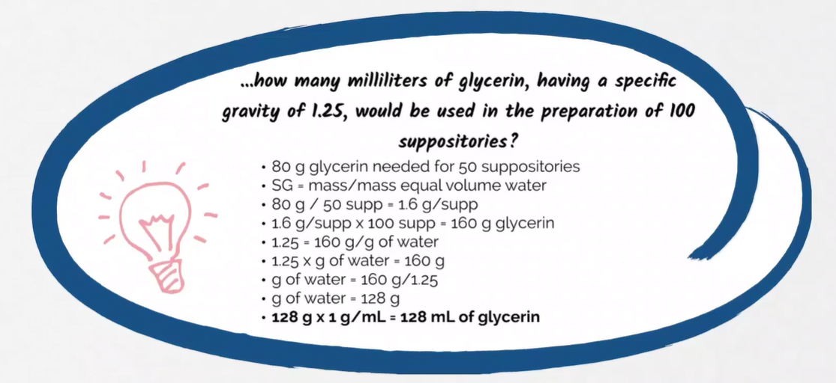

***********************************************************************************************************************

**Ratio and Percentage Strength**

* These equations are used to calculate the amount of different ingredients in mixtures.
* Common terminology for mixtures includes:
  + Solvent or Diluent: Liquid used to dissolve other chemicals (Ex. Water).
  + Solute: Chemicals or medication dissolved in a solution (Ex. Kool-Aid Powder)
  + Solution: Mixture of solvent + solute (Ex. Kool-Aid Drink)

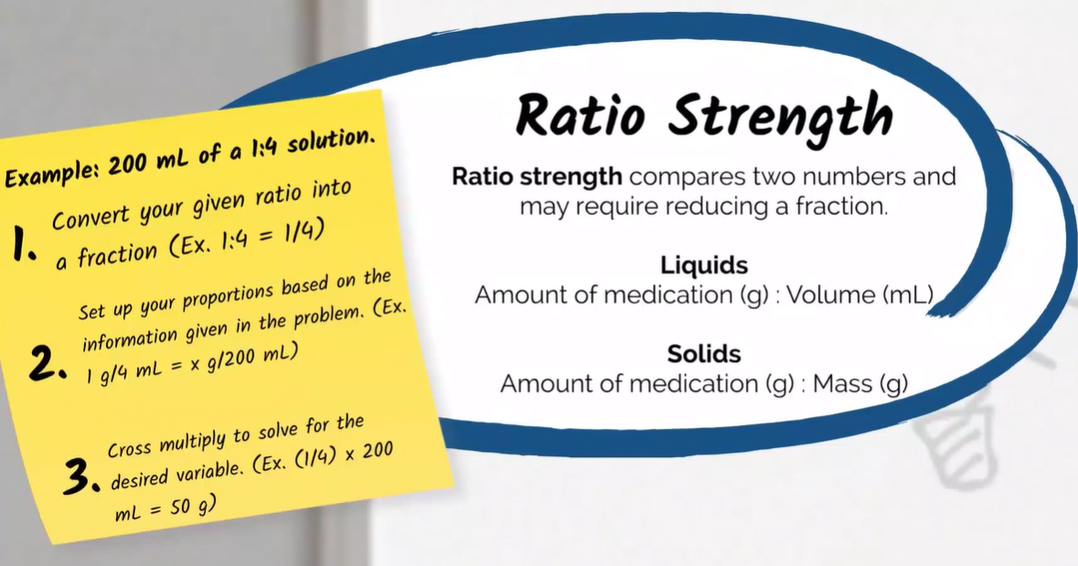

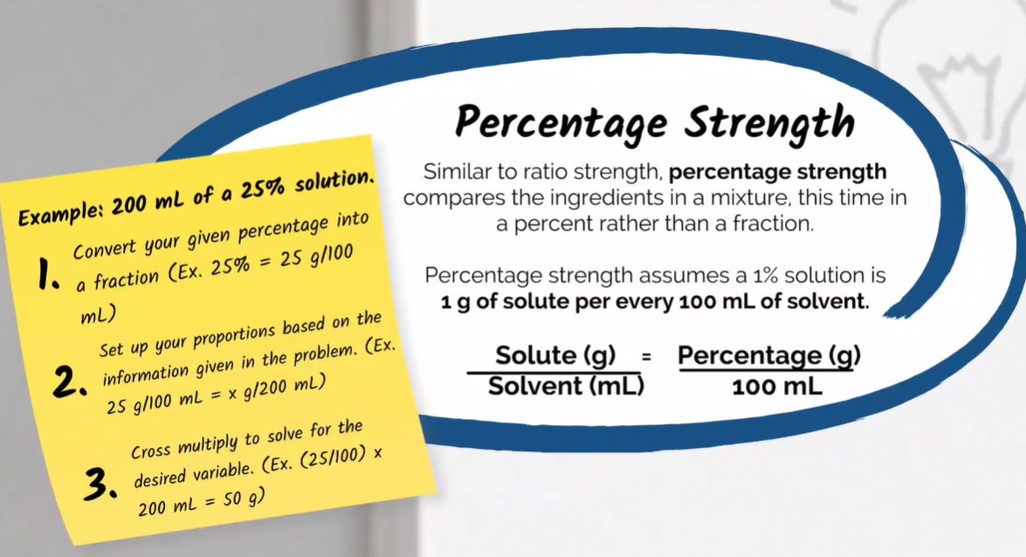

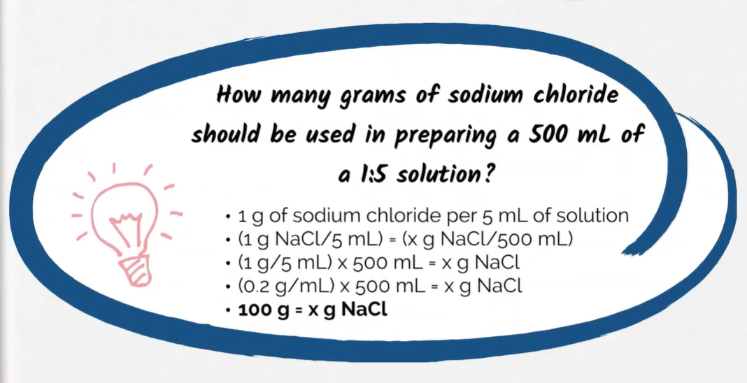

**500 * (1 / 5) = 100g**

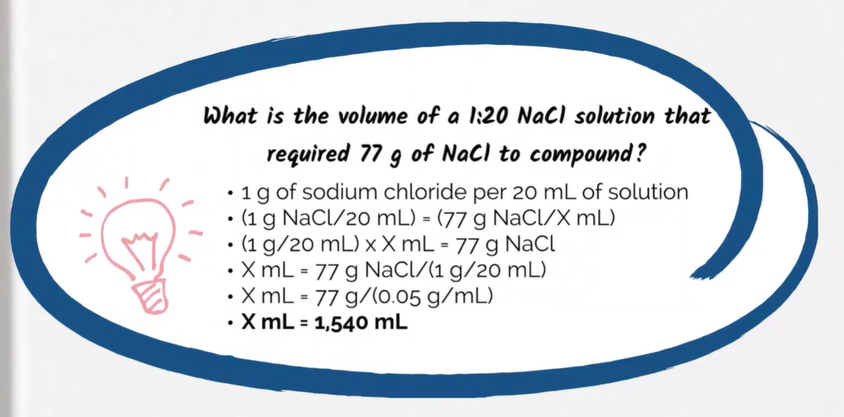

**77 / (1 / 20) = 1540mL**

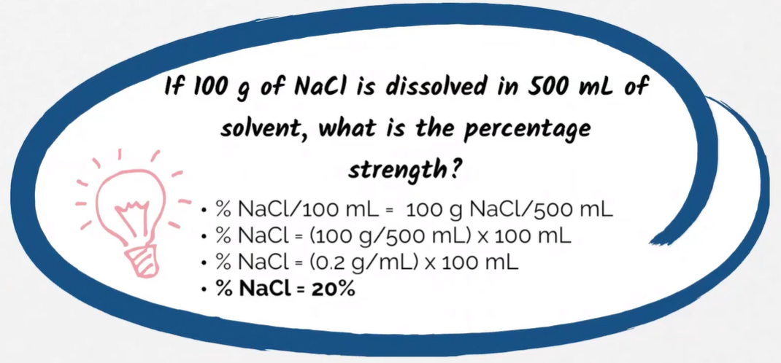

**100 / 500 = 0.2mL or 20%**

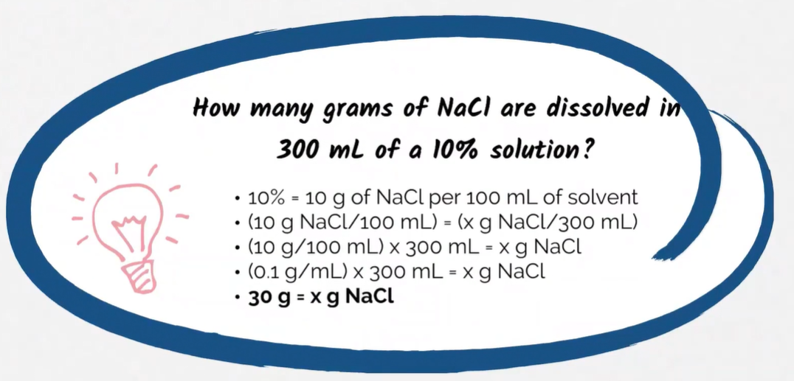

**300 * 0.1 = 30g**

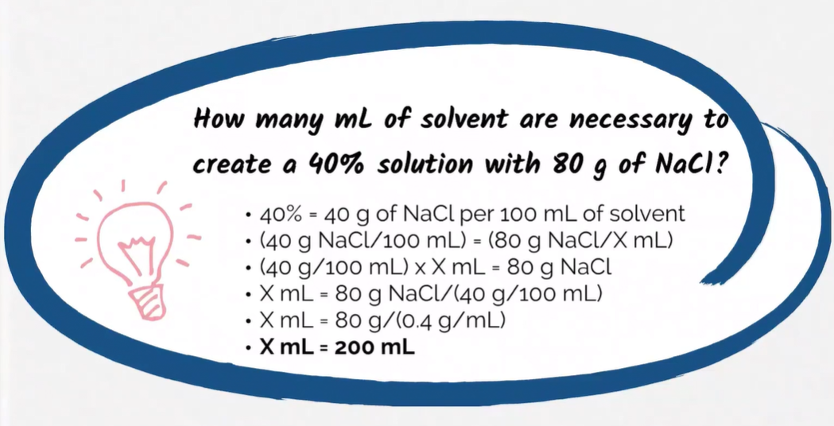

**80 / 0.4 = 200mL**

***********************************************************************************************************************

**Dosing Equations**

* These equations will help you determine different factors associated with prescription quantities and dosages.
* Common terms include:
  + Dose: amount of medication to be taken at one time.
  + Frequency: number of instances per day that the medication is taken.

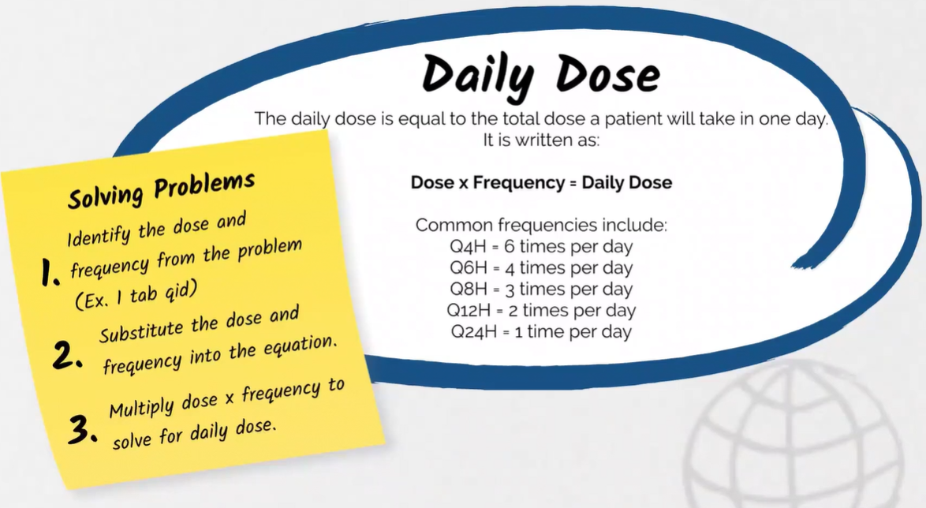

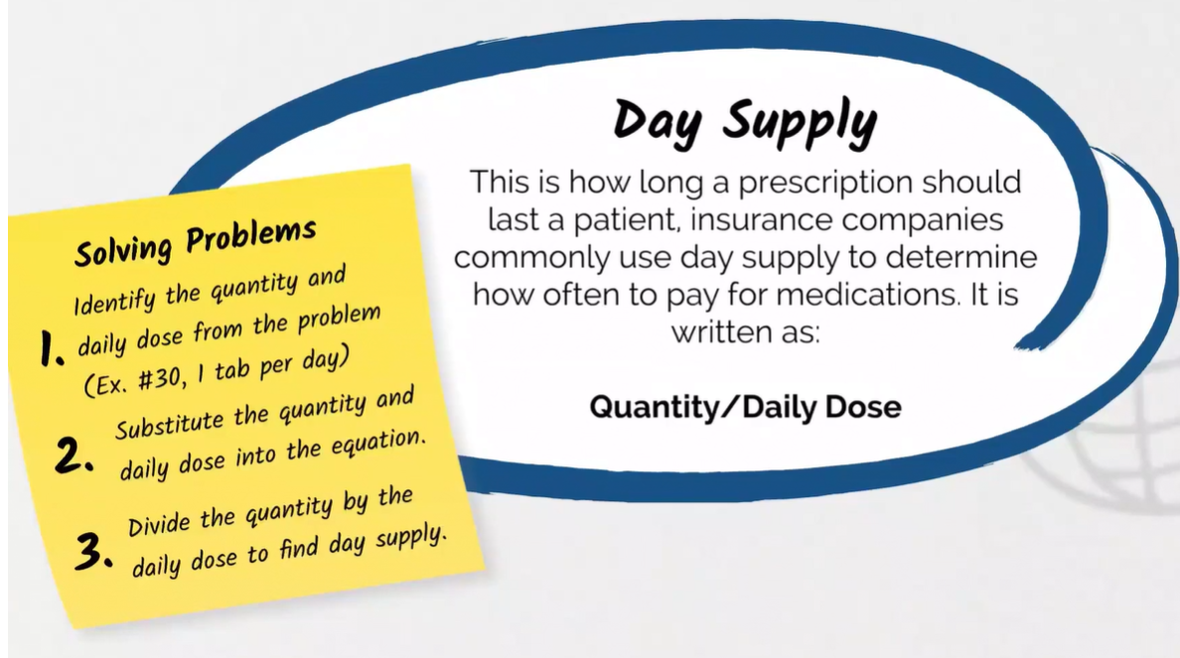

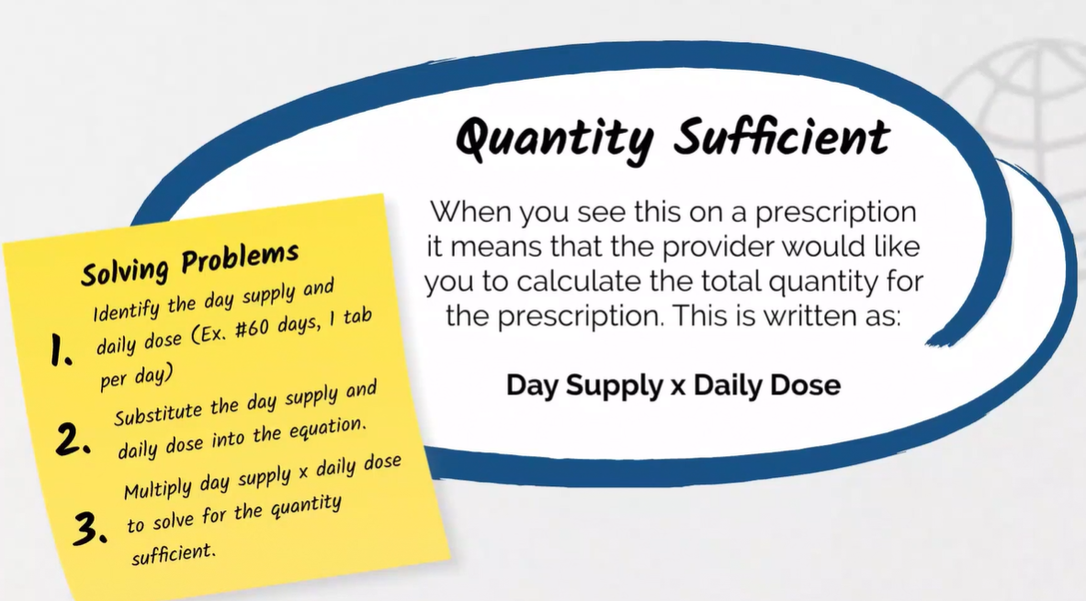

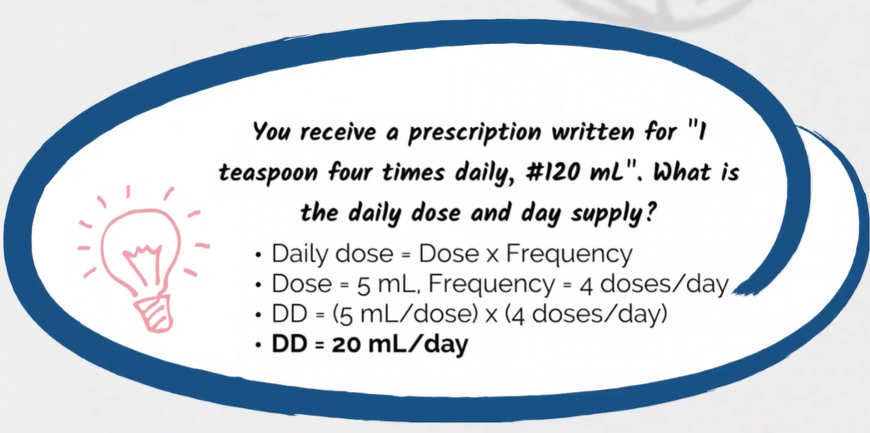

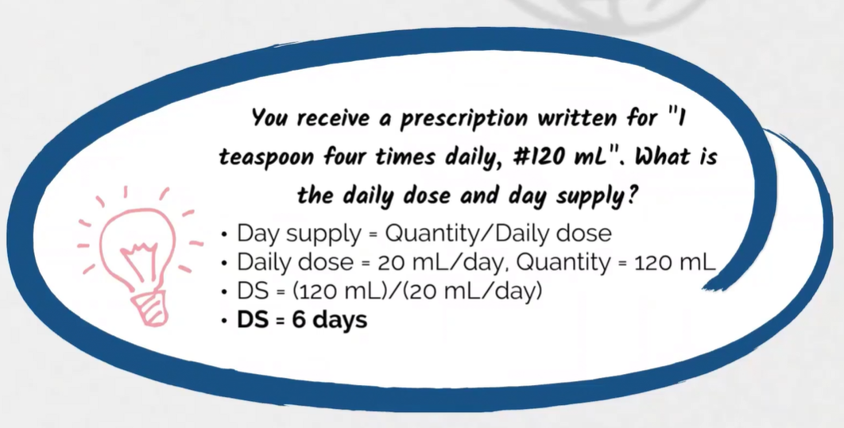

***********************************************************************************************************************

**Children’s Dosing**

* Most children’s doses must be calculated relative to their size when compared to adults.
* These calculations are different ways that you may use to determine a child’s dose for a medication compared to an adult’s dose.

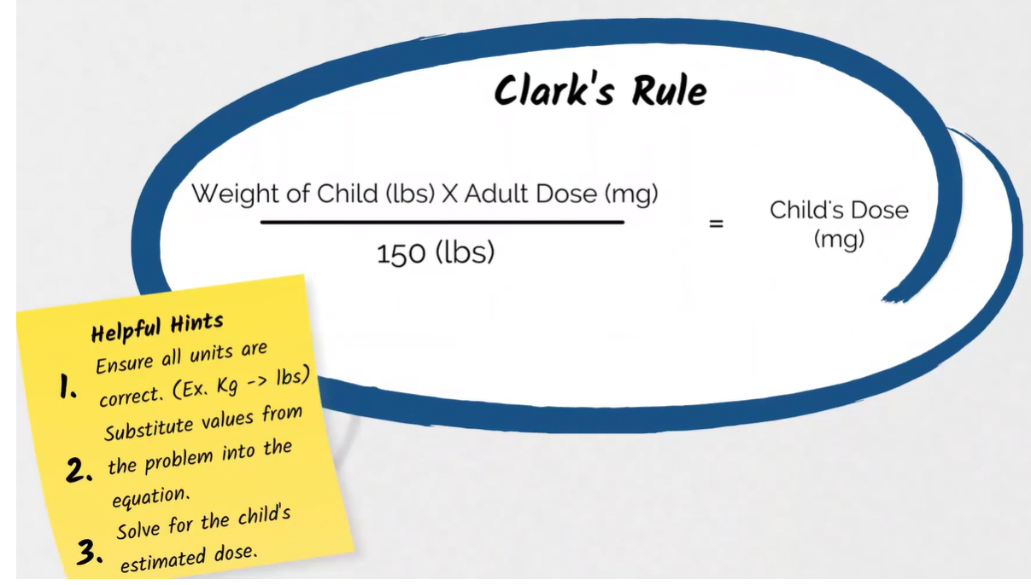

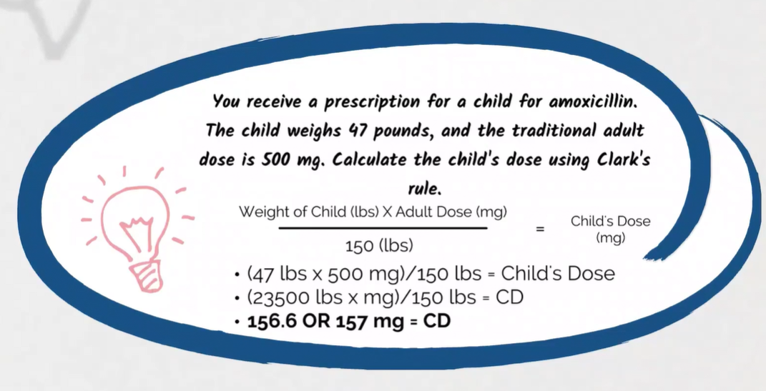

**********************************************************************************************************************

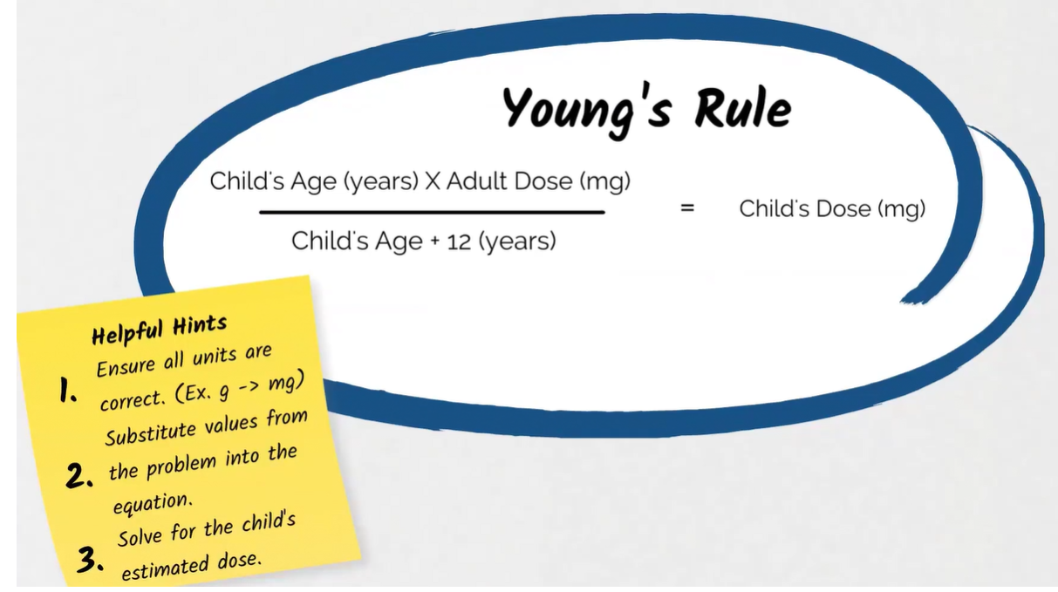

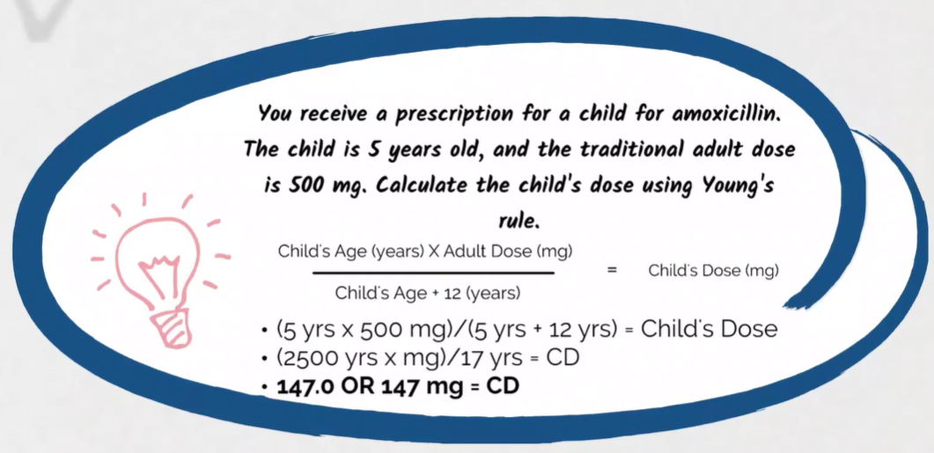

**********************************************************************************************************************

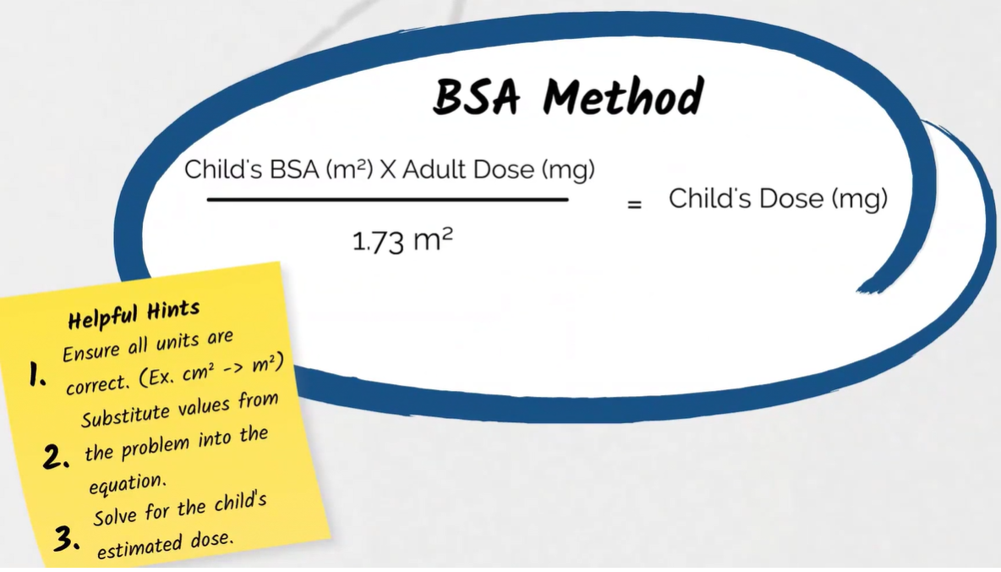

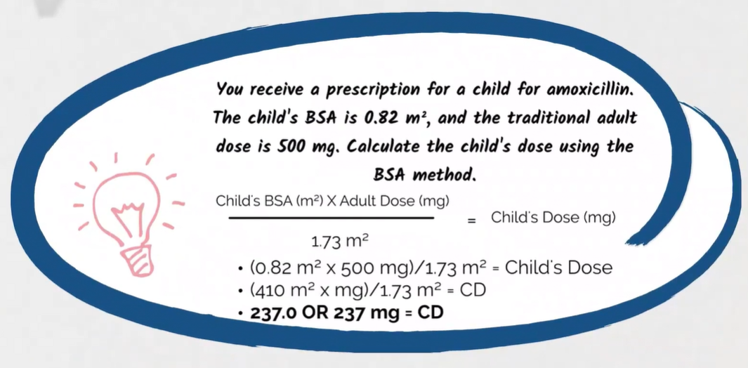

**********************************************************************************************************************

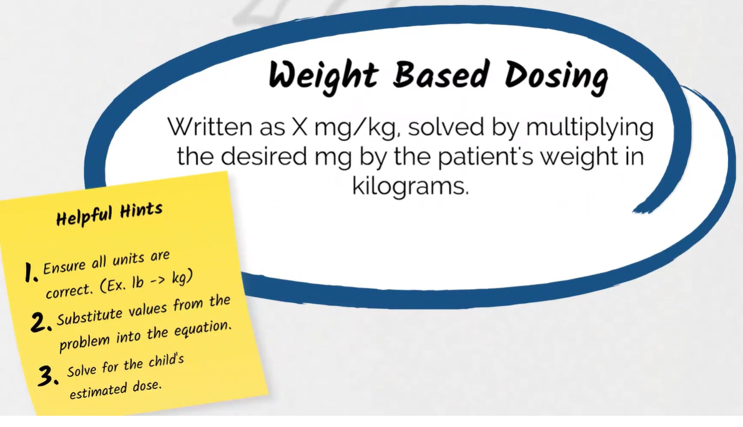

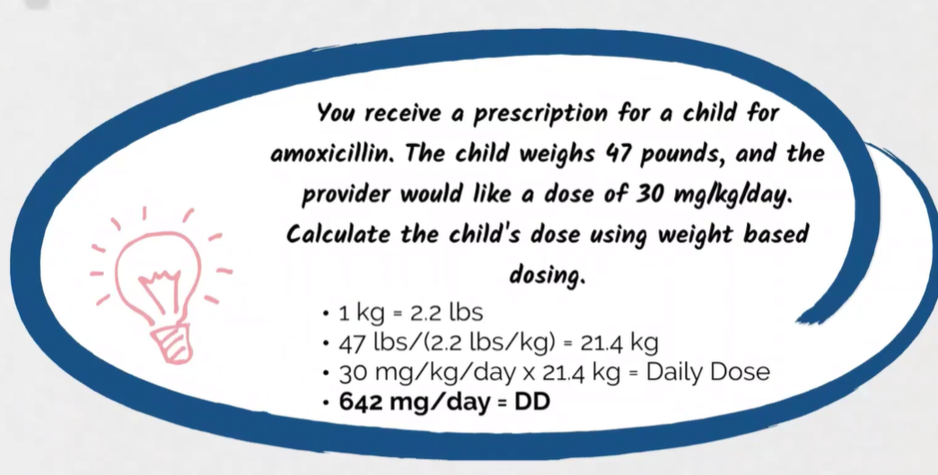

***********************************************************************************************************************

**Infusions**

* These equations are common in hospital pharmacy where intravenous drugs are being compounded and administered.
* Common variables for these equations include:
  + Volume, typically in gtts or mLs.
  + Time, commonly in min or hr.
  + Flow Rate, commonly in gtts/min and mL/hr.

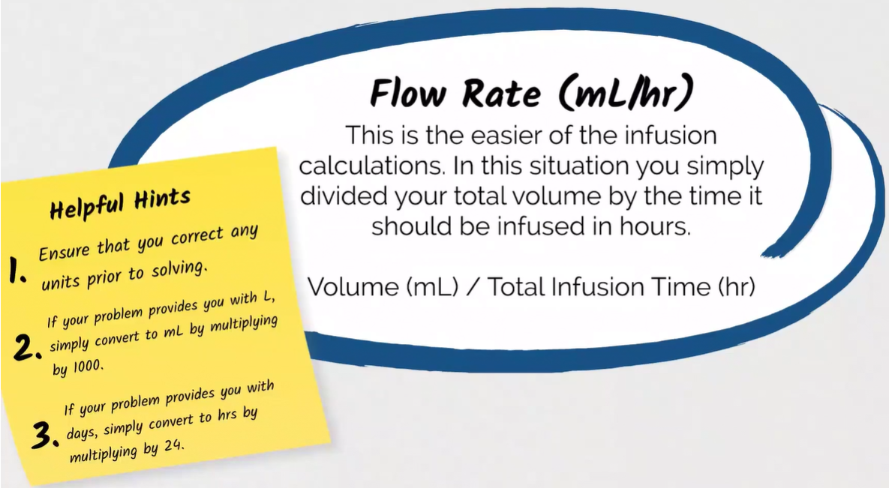

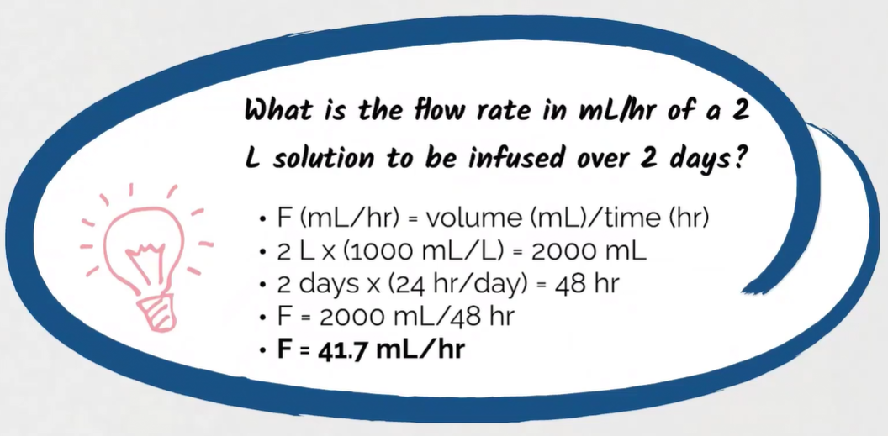

***********************************************************************************************************************

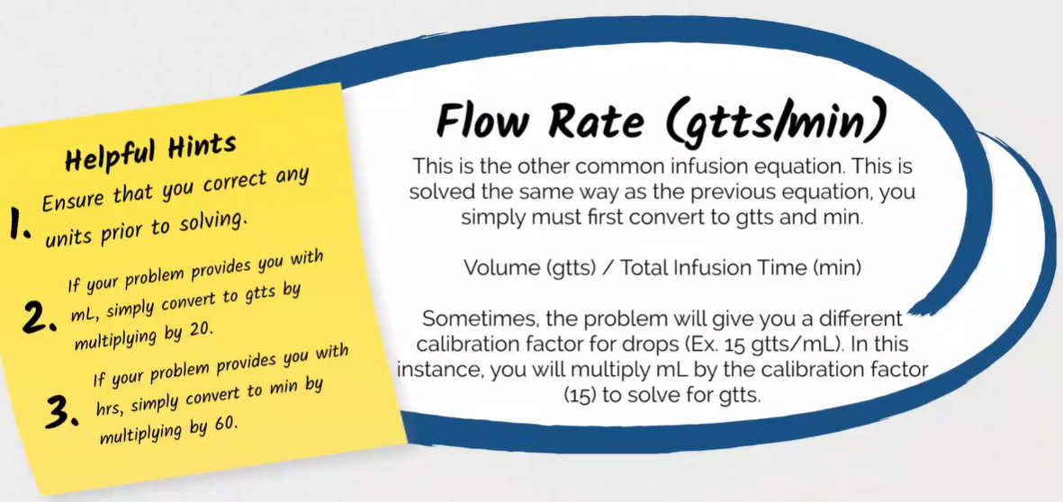

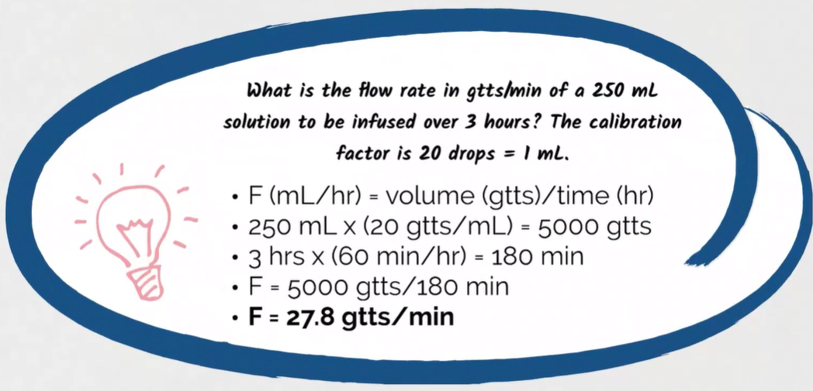

Note*: volume(gtts)/time(min)

***********************************************************************************************************************

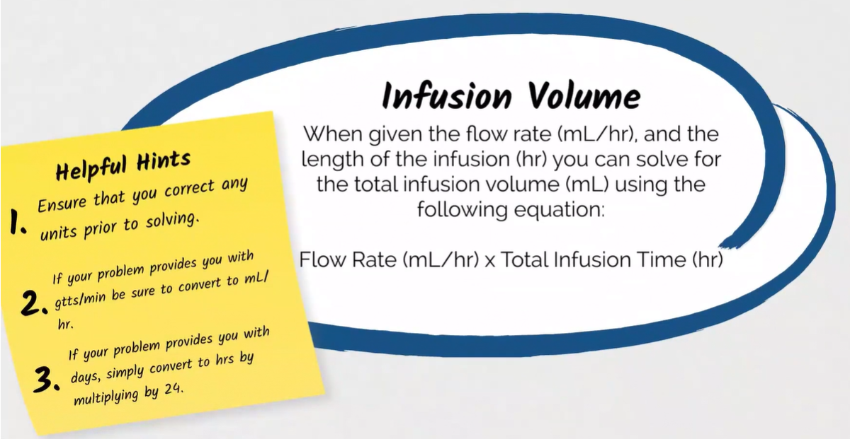

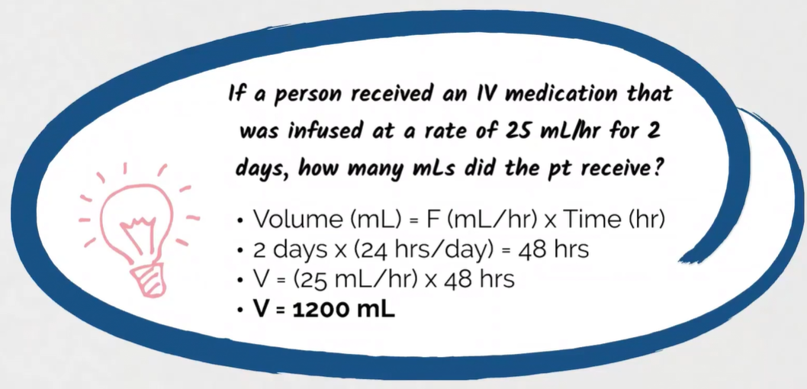

***********************************************************************************************************************

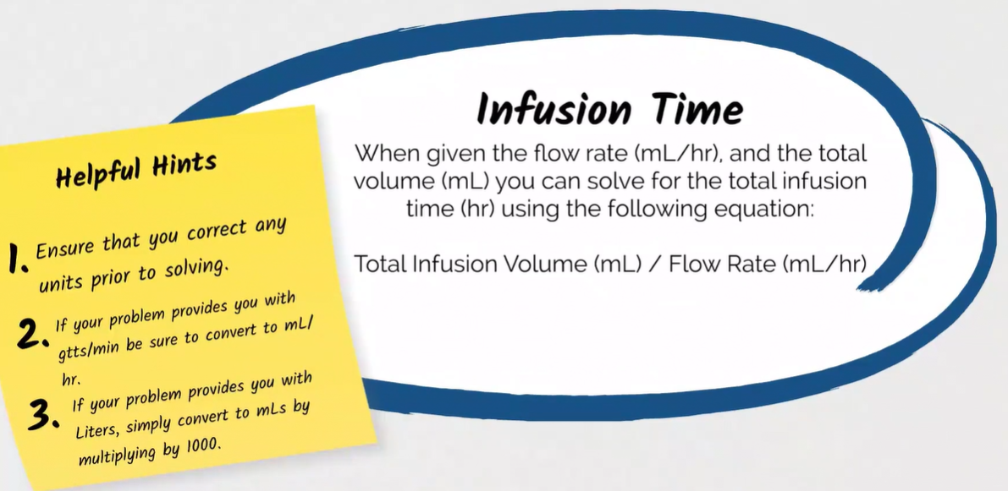

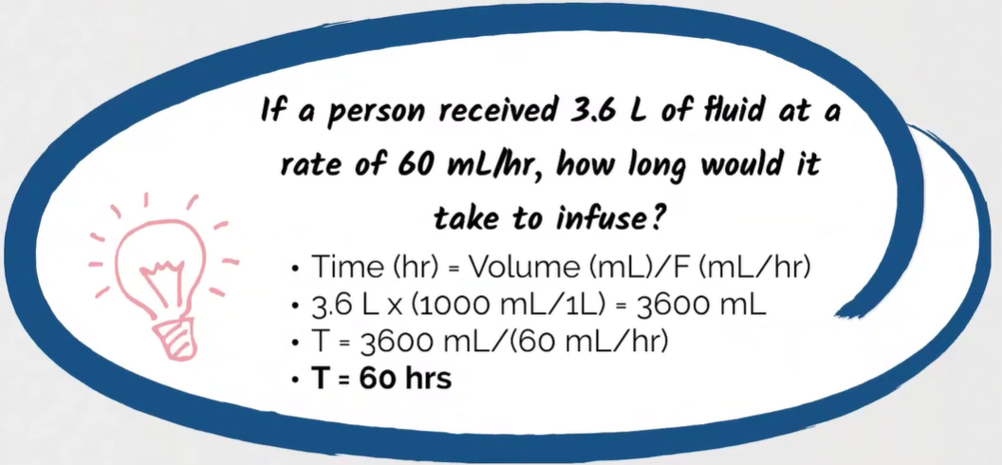

***********************************************************************************************************************

**Dilutions**

* These equations will commonly be used in compounding or hospital pharmacy as you mix two ingredients together to get a diluted strength.
* Common dilutions include % of a liquid, which will commonly be diluted with water or some other non-active ingredient liquid, or % of a solid, which will commonly be diluted with a non-active ingredient solid such as lactose.

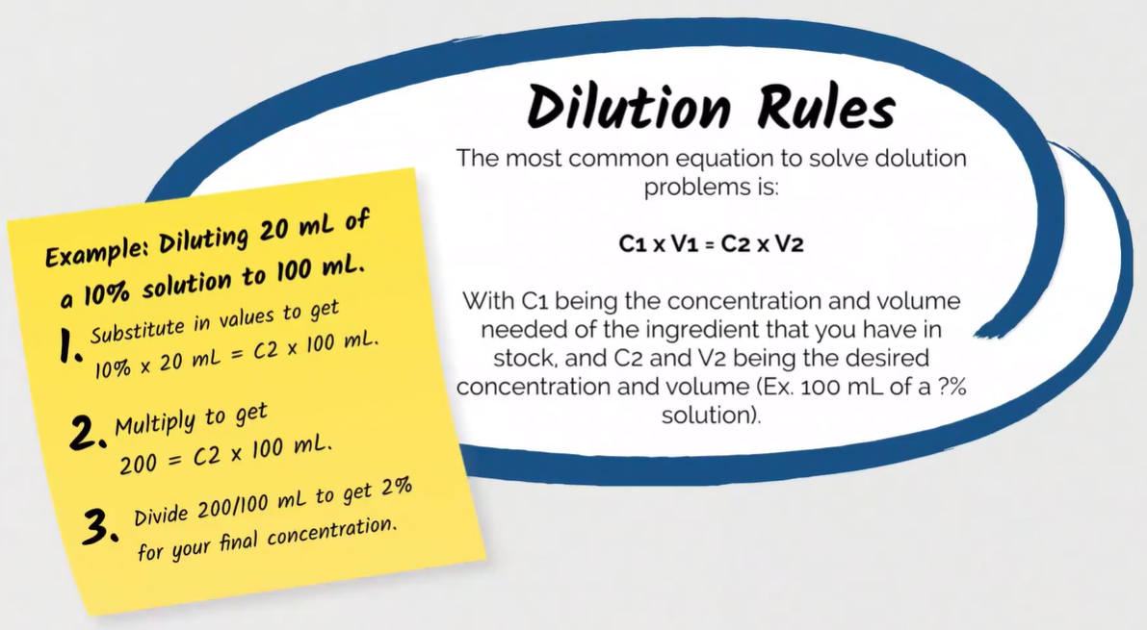

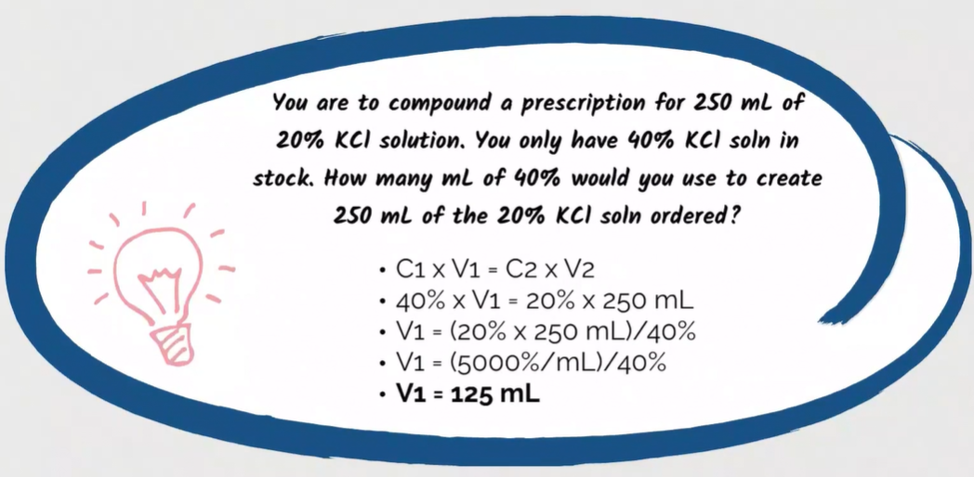

We would need 125mL of 40% KCI.

The other 125mL is water.

This would make 250mL with 20% KCI solution.

***********************************************************************************************************************

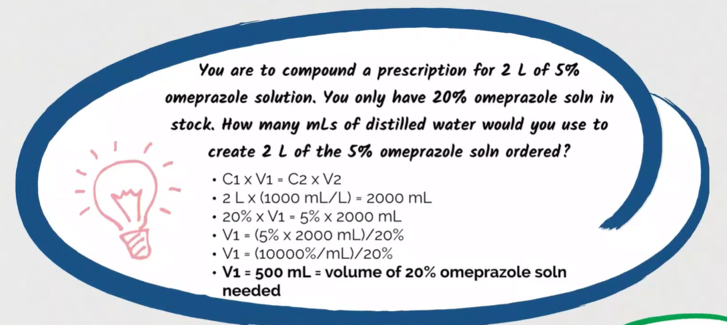

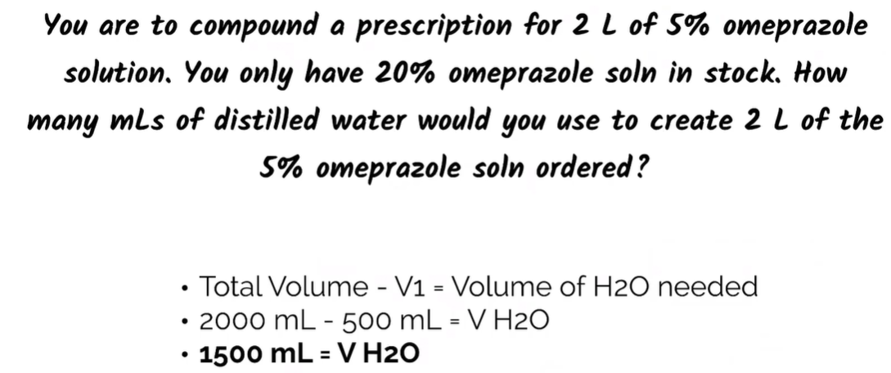

***********************************************************************************************************************

**Alligations**

* Sometimes, a prescription will be written for a strength that you do not have in stock.
* In these situations, you may have to perform an allegation with what products you have in stock to get the desired product strength.
* May need to use 2 different solutions with different strengths to get the desired solution.







